**Experiment – 4: To implement statistical hypothesis tests.**

7. Laboratory Exercise:

T-Test on a sample of ages 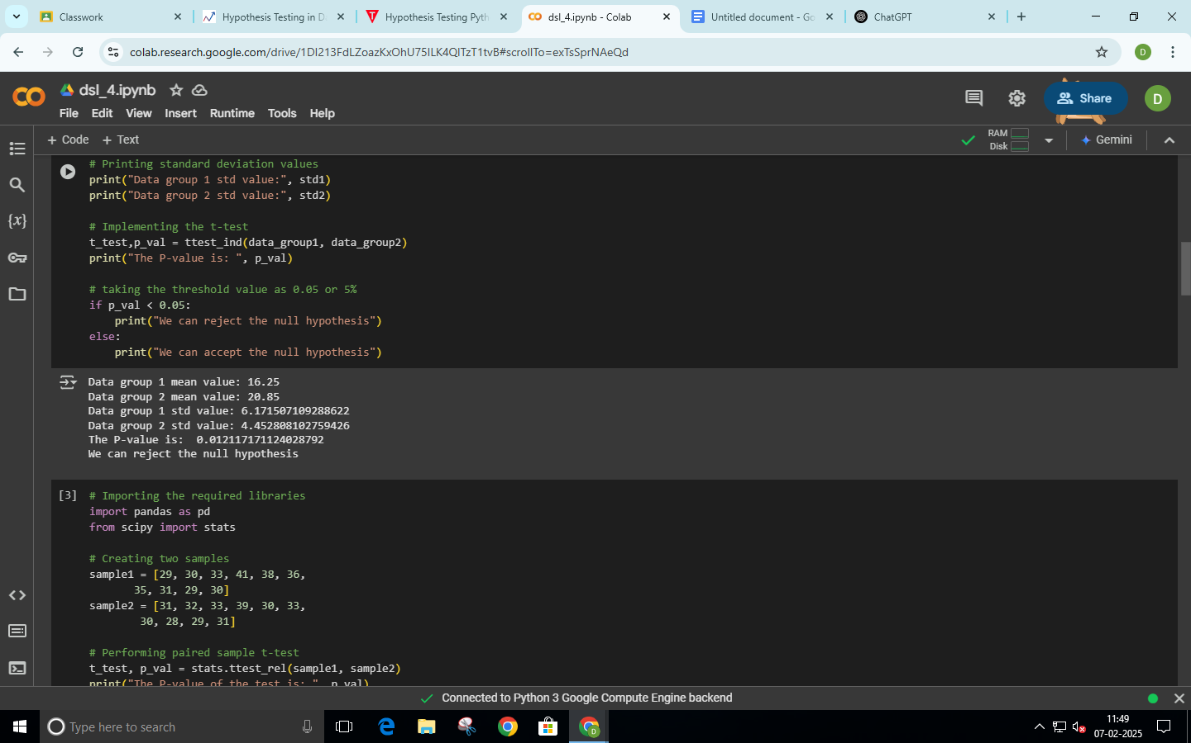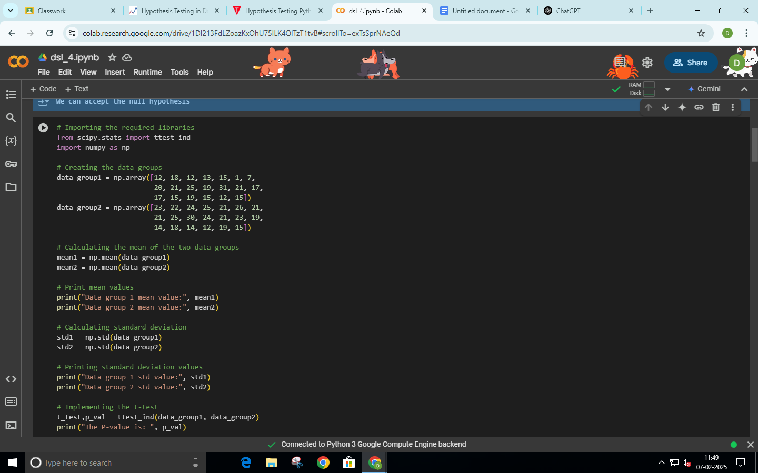

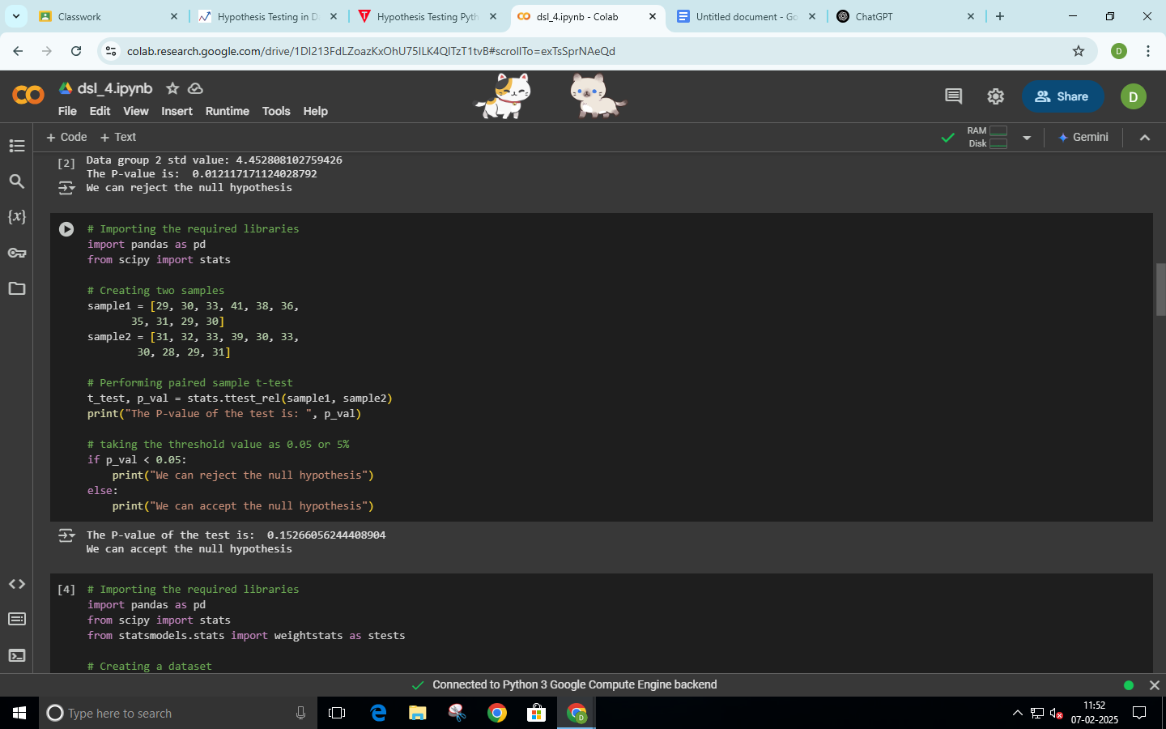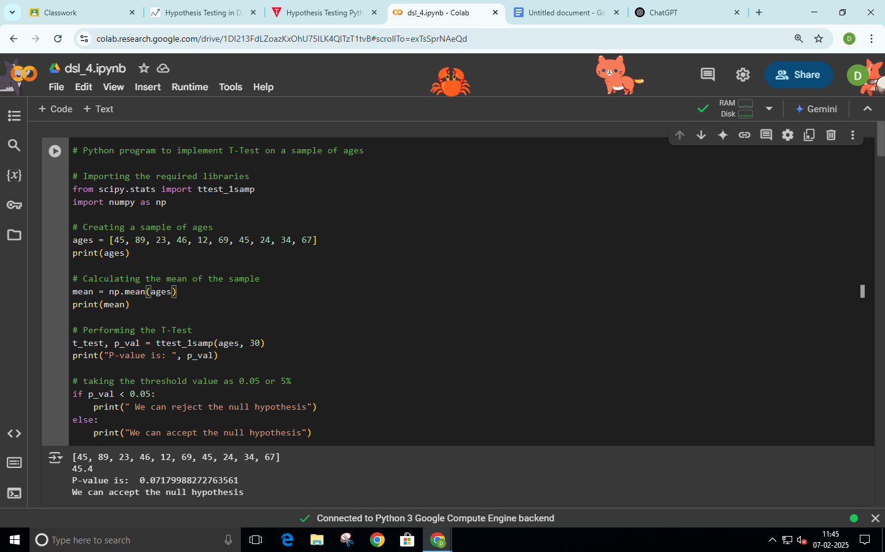

2-way F-test

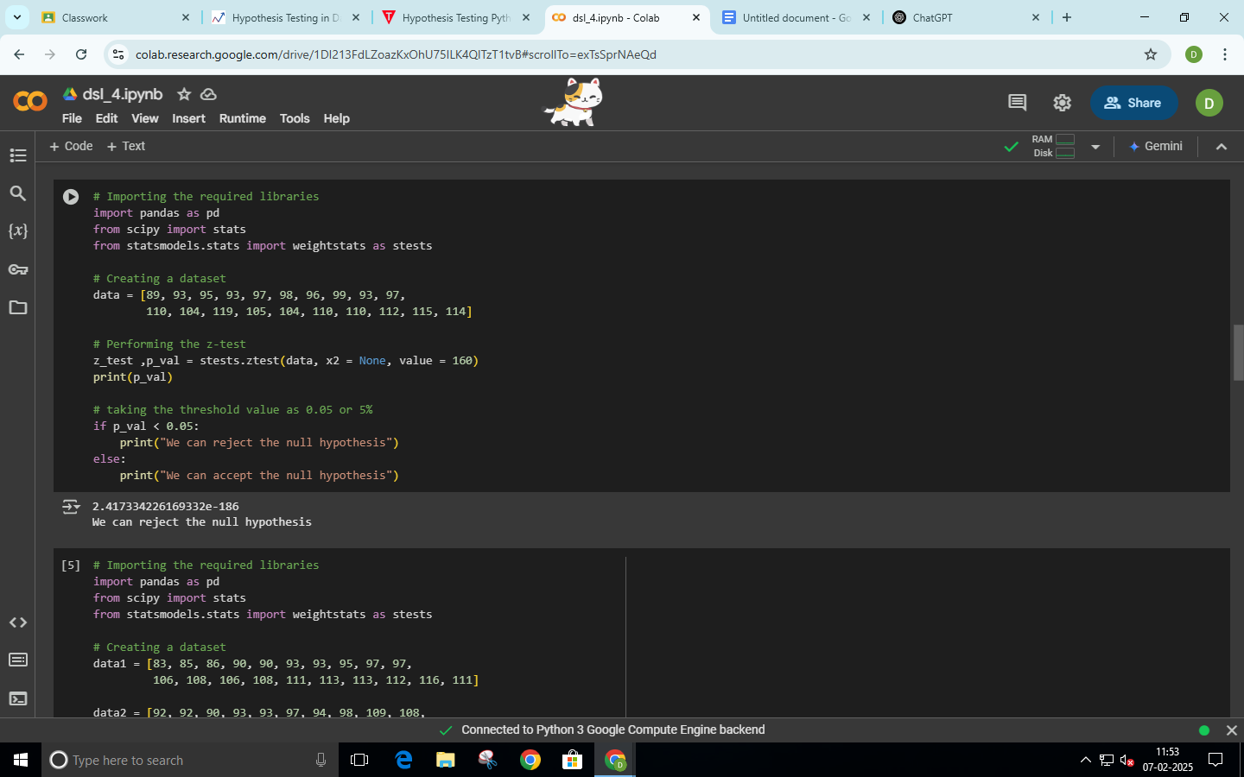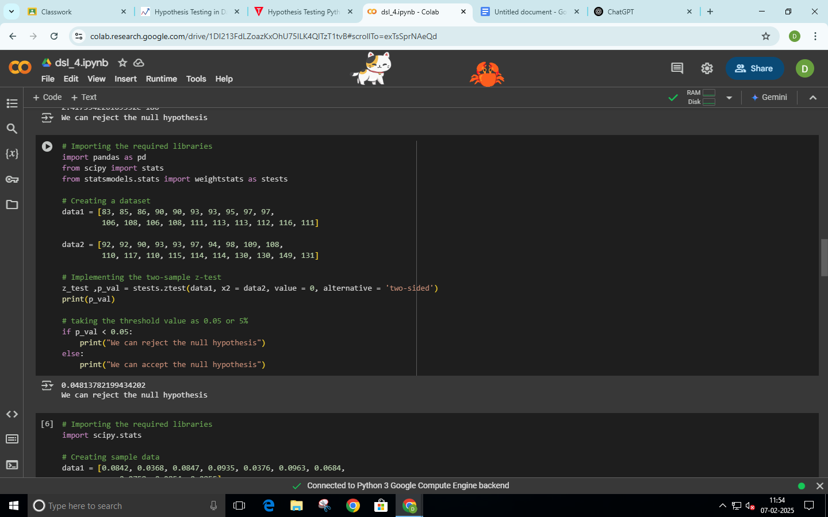



chi-square test

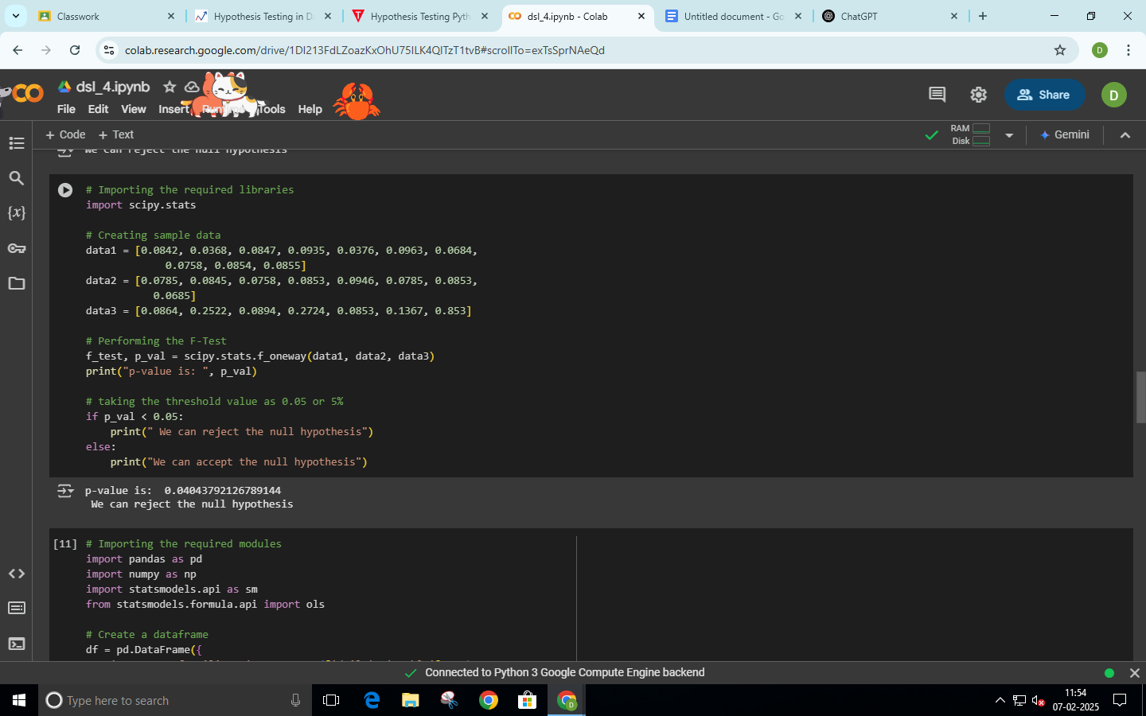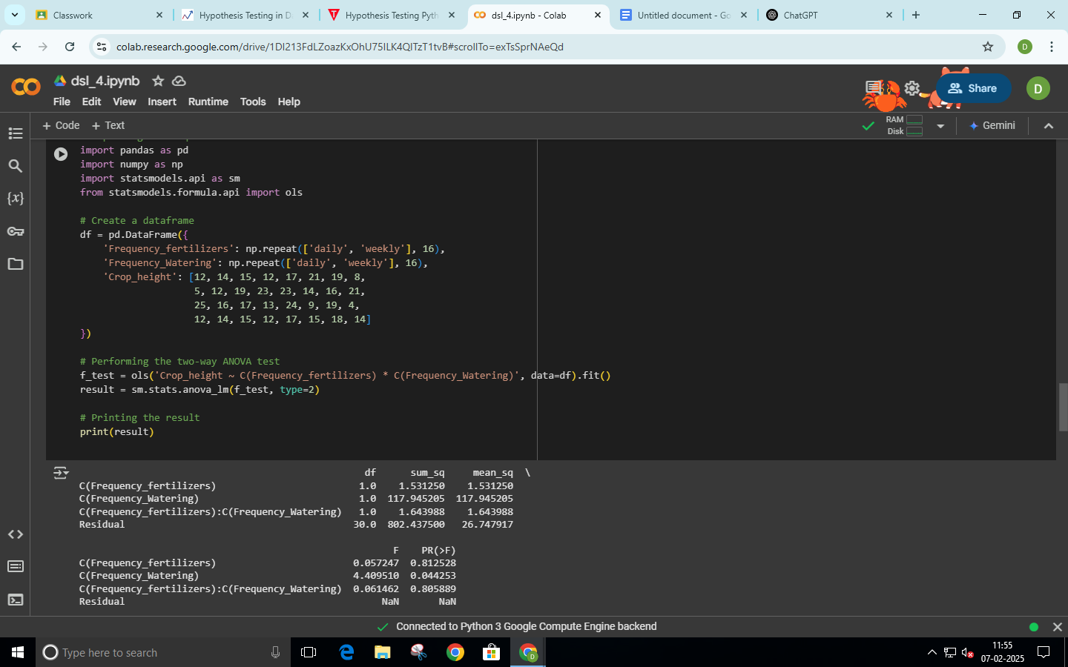

Wilcoxon Signed-Rank Test Kruskal-Wallis H Test

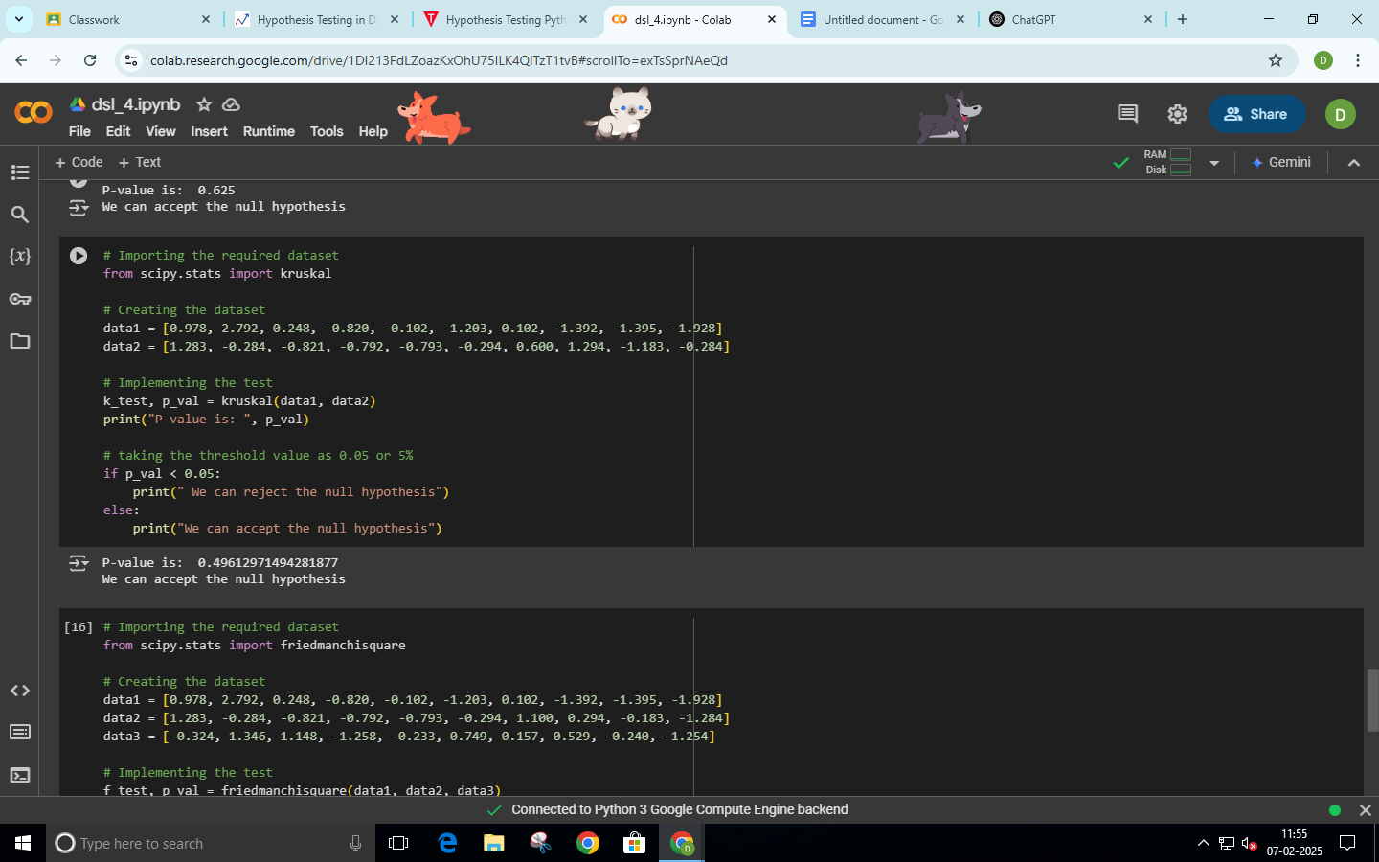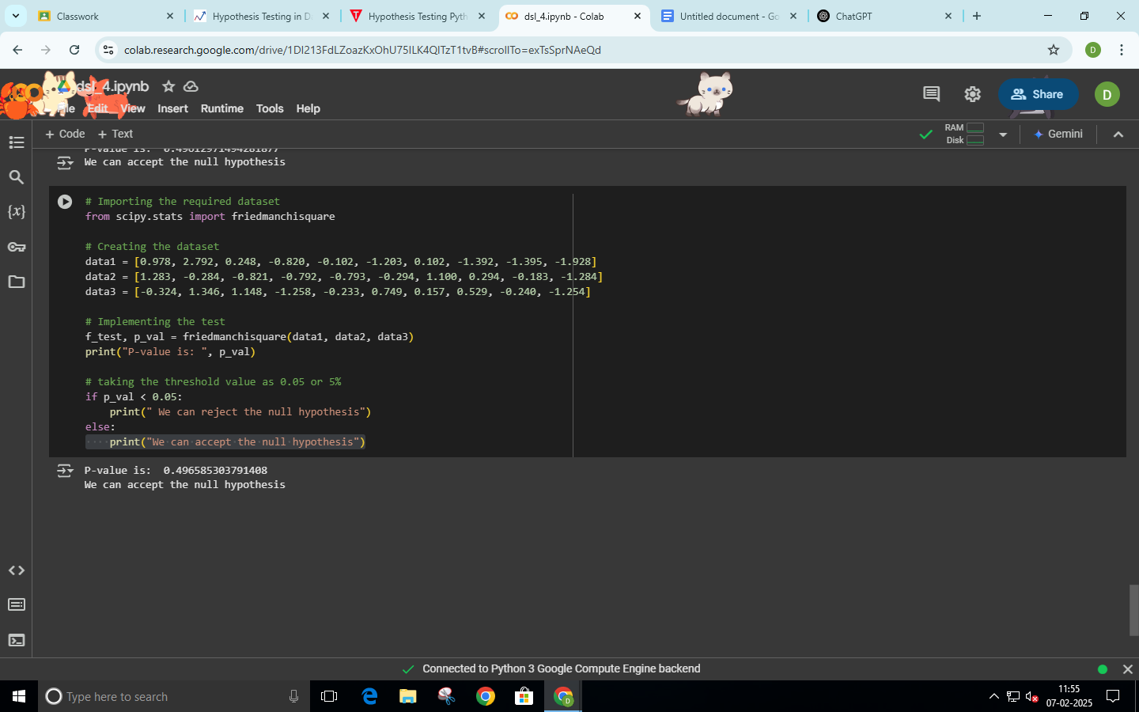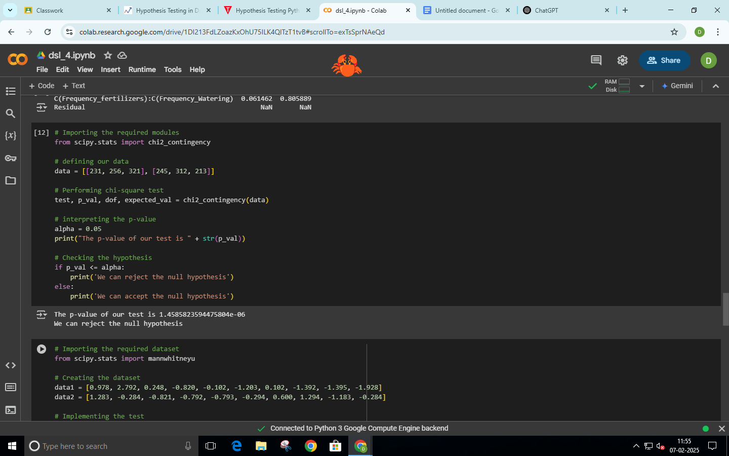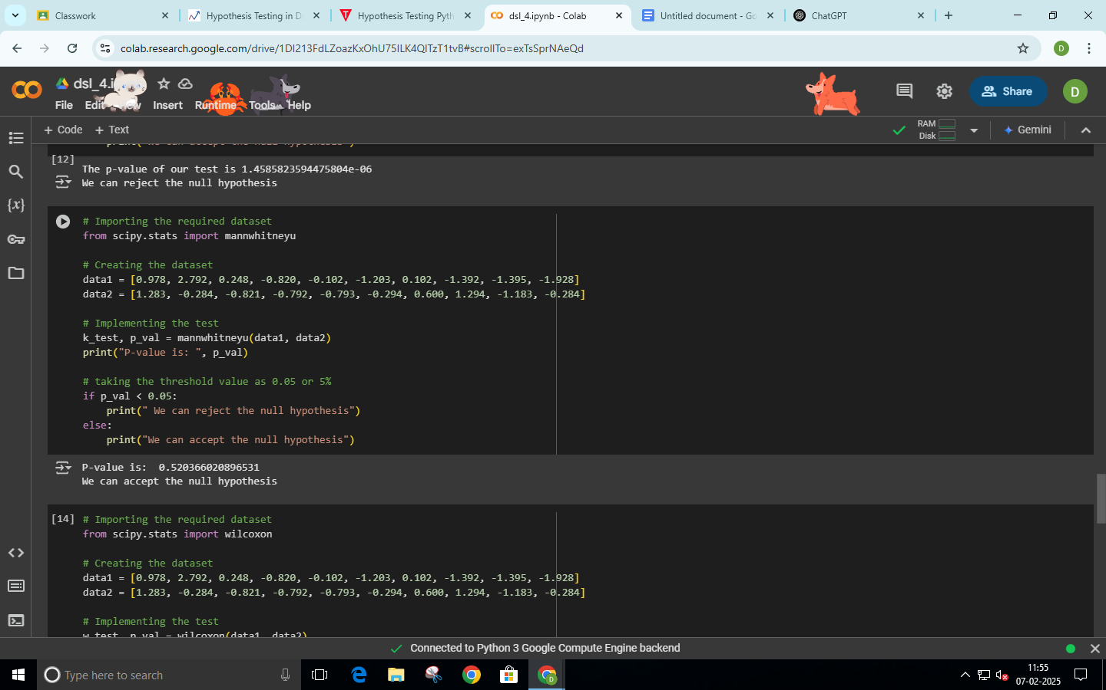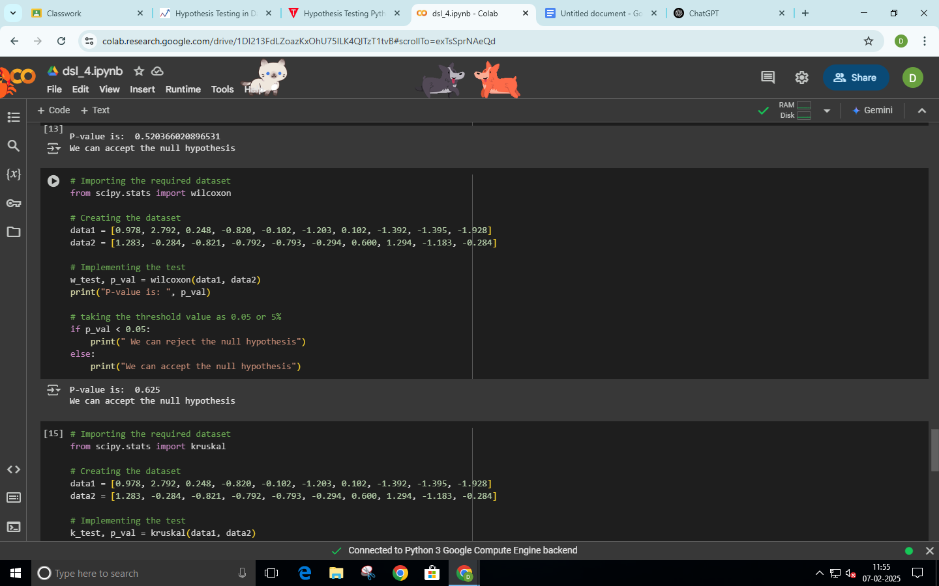

**Example 1**

Problem statement: Assume we are pizza makers and we are interested in checking if the diameter of the Pizza follows a Normal/Gaussian distribution?

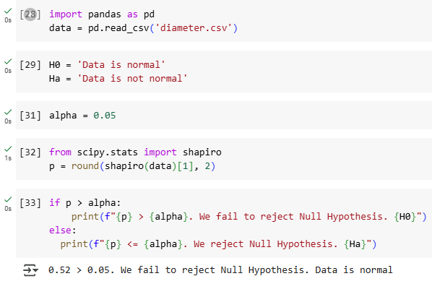

**Example 2**

Problem statement: Assume our business has two units that make pizzas. Check if there is any significant difference in the average diameter of pizzas between the two making units.

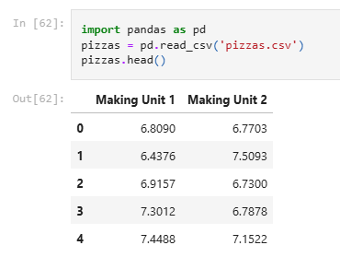

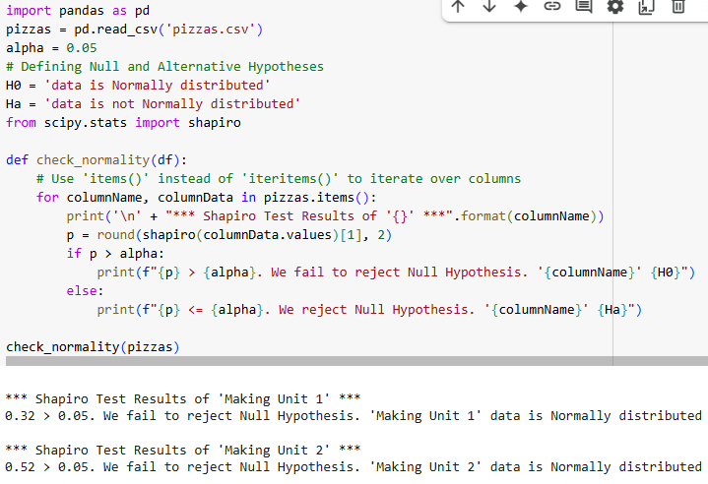

#### 

#### T-test for two samples with equal variances

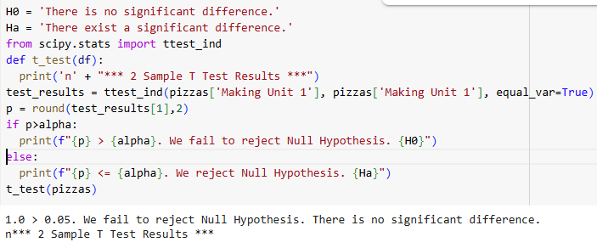

**8. Post-Experiments Exercise**

**A. Extended Theory: (Soft Copy)**

1. **Mention Parametric Statistical Hypothesis Tests**

Student’s t-test: The Student's t-test is used to determine if there is a significant difference between the means of two groups. It assumes that the data is normally distributed and that the variances of the two groups being compared are equal (for the independent t-test). There are different types of t-tests:

a)Independent t-test: Compares the means of two independent groups (e.g., treatment vs control group).

b)Paired t-test: Compares the means of two related groups (e.g., pre-test vs post-test scores for the same subjects).

c)One-sample t-test: Compares the mean of a single group to a known value or population mean.

1. **Nonparametric Statistical Hypothesis Tests**

Mann-Whitney U Test: The Mann-Whitney U Test (also known as the Wilcoxon rank-sum test) is a nonparametric test used to determine whether there is a significant difference between the distributions of two independent groups. Unlike the t-test, the Mann-Whitney U Test does not assume normality of the data. It compares the ranks of the values from both groups to assess whether one group tends to have higher or lower values than the other. This test is used when the data is ordinal or when the assumptions of the t-test (normal distribution) are not met.